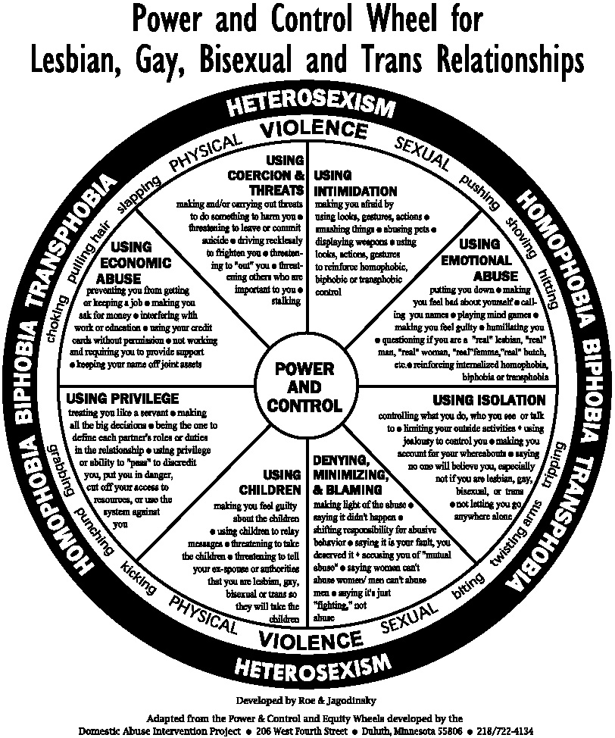

The LGBTQ Power and Control Wheel Highlights

Using Coercion and Threats
Threatening to “out” survivor about sexual orientation or HIV status to employers, family, churches, friends, etc.
Threatening to out undocumented, immigrant partner to INS
Using Intimidation
Using looks, actions, gestures to reinforce homophobic control
Using Emotional Abuse
Saying you are not a “real” lesbian/gay man unless you stay
Reinforcing internalized homophobia
Using Isolation
Using sexual orientation to distance survivor from family, friends, churches
Saying no one will believe survivor because s/he is LGBTQ
Saying batterer is the only one who will love survivor because survivor is LGBTQ

Denying, Minimizing, and Blaming
Saying all LGBTQ relationships are like this
Accusing survivor of “mutual” abuse
Saying all men hit each other/ women can’t abuse each other
Using Children
Threatening to tell authorities about LGBTQ identity and to have kids taken away
Threatening to disallow survivor to see batterer’s biological children (if survivor does not have custody rights
Using Privilege
Using homophobic systems to reinforce survivor’s subservient status
Using class/race/gender privilege to control survivor
Using Economic Abuse
Threatening to out survivor to employers
Refusing to share resources, using not being able to marry as excuse

Beyond the Wheel

Additional forms of Physical and Sexual Abuse
Forcing survivor to have sex to prove she’s really a lesbian/ he’s really a gay man
Using shame surrounding LGBTQ sexuality to keep survivor from talking about sexual abuse
Hiding or destroying survivor’s hormones (for transgendered survivors) or HIV/AIDS medications (for HIV+ survivors)
Making survivor vulnerable to hate crimes

Additional Barriers Abusers May Exploit
Homophobia of police, hospital personnel, court officials, service providers, etc. –to convince survivor that no one will listen to or help her/him or to guilt survivor into not exposing the batterer to harm
Inability of gay men or transgendered people to access most shelters
Ease with which women abusers can access shelters and with which same-sex abusers can access hospital rooms, bathrooms, and other “safe” spaces.
Abuser’s own vulnerabilities (ex. HIV+ status, not being “out”) to shame survivor into staying
Difficulties for survivor in staying safe or away from abuser in small, insular communities
Impossibility, in some jurisdictions, for survivors to get civil protection orders
